# Exploring an End-to-End AI Solution: Google Maps

## 1. Introduction

Google Maps is one of the most utilised AI-powered applications today. Originally launched to provide navigation and location services, the platform has evolved to integrate advanced artificial intelligence capabilities. These enhancements enable real-time traffic prediction, personalized recommendations, route planning and even generative search experiences. This report delves into the technical workings behind these features—particularly the ML models that drive traffic estimation and user personalization—while also examining the platform’s end-to-end architecture and underlying data sources.

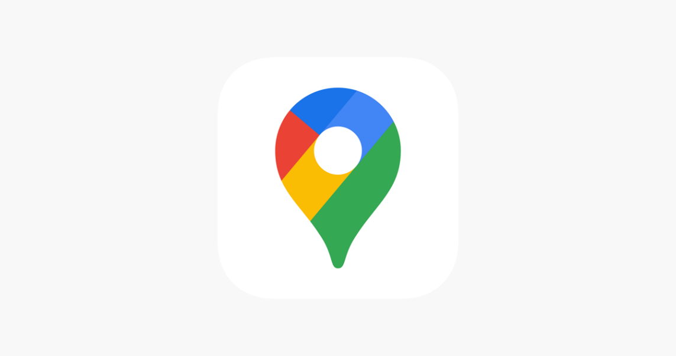

## 2. Platform Overview

### Primary Use Cases

Google Maps serves a wide range of functions:

* **Navigation & Route Planning:** Delivering real-time directions, calculating estimated time of arrival (ETA), and dynamically rerouting users based on current road conditions.
* **Traffic Prediction:** Leveraging historical and live data to forecast traffic congestion and improve route efficiency.
* **Personalized Recommendations:** Offering tailored suggestions for restaurants, attractions, and services based on user preferences and contextual factors.
* **Immersive Exploration:** Using features like Immersive View to blend Street View, satellite imagery, and generative AI for a more engaging exploration experience.

### Types of Users

Google Maps is designed for a broad spectrum of users:

* **Everyday Users:** Drivers, pedestrians, and cyclists seeking reliable navigation and real-time traffic updates.
* **Business Analysts & Urban Planners:** Professionals leveraging detailed traffic, transit, and location data to make informed decisions.
* **Developers:** Utilizing APIs and SDKs to integrate mapping and AI-driven functionalities into their own applications.
* **Local Guides & Contributors:** Community members who enhance map data through reviews, images, and on-the-ground feedback.

### Key Technologies

The platform’s success is built on a fusion of several advanced technologies:

* **Machine Learning & Deep Neural Networks:** Employed for traffic prediction and dynamic route optimization.
* **Graph Neural Networks (GNNs):** Specifically used to model road networks and predict ETAs by processing complex spatiotemporal data.
* **Generative AI Models (e.g., Gemini):** Integrated for personalized recommendations and natural language query responses.
* **Voice Recognition & NLP:** Enabling hands-free interaction and context-aware search functionality.
* **Computer Vision:** Enhancing image-based features like Immersive View and extracting text from Street View imagery.

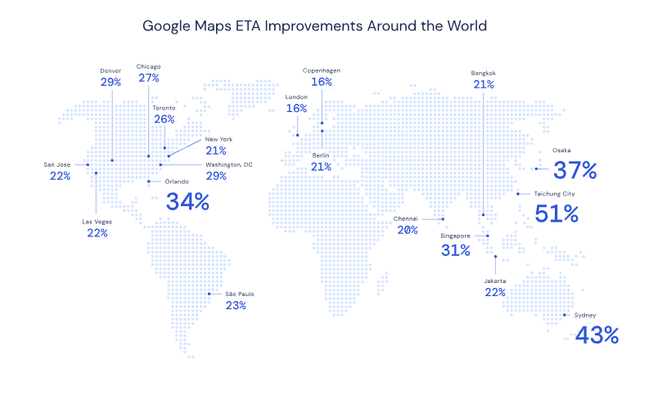

## 3. ML Model Exploration

### Traffic Prediction via Graph Neural Networks

Google Maps’ ability to deliver highly accurate travel time estimates and real-time traffic forecasts is powered by advanced machine learning techniques—most notably, Graph Neural Networks (GNNs). By fusing live sensor data with historical traffic patterns, the system creates a dynamic model of road networks that can predict future conditions with exceptional accuracy.

### How It Works

* **Data Integration:**  
  The system continuously gathers live traffic speeds, incident reports, road quality metrics, and historical data from diverse sources including smartphones, local governments, and user inputs. This rich data set forms the foundation for understanding current conditions and anticipating future traffic flows.
* **Supersegment Modeling:**  
  Roads are divided into “supersegments” — clusters of adjacent road segments that share similar traffic volumes. Each supersegment is represented as a graph, where:
  + **Nodes** correspond to individual road segments.
  + **Edges** capture the connectivity and flow between these segments.  
    This graph-based abstraction enables the model to reflect the real-world structure of road networks.
* **Graph Neural Networks:**  
  GNNs process these supersegment graphs through message passing algorithms that propagate information between connected nodes. This allows the model to learn complex spatiotemporal interactions, capturing how traffic on one road segment affects neighboring segments. To ensure stability and scalability, advanced training techniques such as adaptive learning rate methods are used to dynamically tune the model during training.

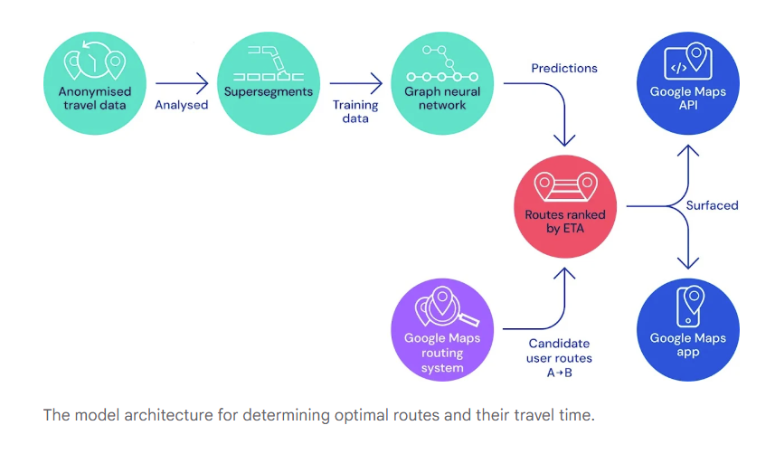

### Beyond Navigation: Enhancing User Experience with Generative AI

Google Maps is evolving into a comprehensive, AI-powered travel assistant by integrating generative AI features:

* **Generative Query Responses:**  
  Users can ask open-ended questions—like “find a quiet cafe near me” or “what fun things to do tonight?”—and large language models analyze the vast dataset of reviews, ratings, and photos to provide personalized recommendations.
* **Review Summarization:**  
  Instead of sifting through millions of reviews, users receive concise summaries that help them quickly make informed decisions.
* **Dynamic Itinerary Planning:**  
  Conversational AI supports real-time, context-aware itinerary adjustments, offering recommendations that adapt to users’ changing needs.

### Additional AI-Powered Enhancements

* **Voice Recognition:**  
  Deep learning–based speech recognition enables safe, hands-free interactions by accurately converting spoken commands into navigation actions.
* **Immersive View:**  
  By combining computer vision with generative AI, Immersive View creates photorealistic 3D renderings of environments, enhancing exploration in over 150 cities worldwide.
* **Automatic Detour Calculations:**  
  AI algorithms monitor real-time data to detect incidents like accidents or road closures and promptly recommend alternative routes.

## 4. Conclusion

Google Maps stands out as a perfect example of an end-to-end AI solution that integrates a diverse range of advanced technologies—from deep neural networks and graph-based models to generative AI and voice recognition—to deliver an effective, efficient, personalized and user-friendly experience. Its ability to predict traffic using sophisticated GNN models, dynamically recommend personalized itineraries, and continuously improve through real-time data and adaptive learning underscores the platform’s technical depth and innovative edge.

The exploration of Google Maps reveals how integrating multiple AI models not only enhances navigational accuracy but also transforms the user experience into a holistic digital companion for both everyday travel and exploratory adventures.

## 5. References

1. **The Verge – How Google Maps uses AI to predict your arrival time**  
   <https://www.theverge.com/2020/9/3/21419632/how-google-maps-predicts-traffic-eta-ai-machine-learning-deepmind>
2. **Traffic prediction with advanced Graph Neural Networks**

<https://deepmind.google/discover/blog/traffic-prediction-with-advanced-graph-neural-networks/>

1. **Reuters – Google Maps AI Enhancements**  
   <https://www.reuters.com/technology/artificial-intelligence/google-brings-ai-answers-map-applications-2024-10-31/>
2. **Axios – Google infuses its maps with generative AI**  
   <https://www.axios.com/2024/10/31/google-maps-waze-generative-ai>
3. **arXiv – Graph Neural Networks: A Review of Methods and Applications**  
   <https://arxiv.org/abs/1812.08434>
4. **A new way to discover places with generative AI in Maps**

<https://blog.google/products/maps/google-maps-generative-ai-local-guides/>

1. **New Maps updates: October 2023**

<https://blog.google/products/maps/google-maps-october-2023-update/>

1. **Google Maps 101: How AI helps predict traffic and determine routes**

<https://blog.google/products/maps/google-maps-101-how-ai-helps-predict-traffic-and-determine-routes/>

1. **How Google Maps Uses AI & ML**

<https://mapsplatform.google.com/resources/blog/how-google-maps-platform-uses-aiml-and-community-contributions-keep-its-points-interest-date/>

1. **Google Maps with ML**

<https://medium.com/@dinukamarlon/google-maps-with-machine-learning-d9b51db22b49>